**I. Magnetic Field Vectors**

We are going to use the following simulation to see what would happen if you put a compass at various locations around a bar magnet:

<https://phet.colorado.edu/sims/cheerpj/faraday/latest/faraday.html?simulation=faraday>



* Make sure that you are in the “Bar Magnet” tab of the simulation
* De-select the “Show Field” box in the Bar Magnet window

1. Use your mouse to move the compass around the bar magnet. You should move the compass around the magnet in a circle. How is the compass behaving?

As the compass is moving around the bar magnet the north and south poles of the compass are oppositely attracted to the north and south poles of the bar magnet.

1. Which way are the compass arrows pointing relative to the North and South Poles of your magnet?

When the compass is within range of the south pole the north arrow of the compass points towards the south pole of the bar magnet and vice versa.

1. Place the compass at 6-8 different points around the magnet. Draw arrows for the direction of the red part of the compass on the corresponding grid points on the figure below.

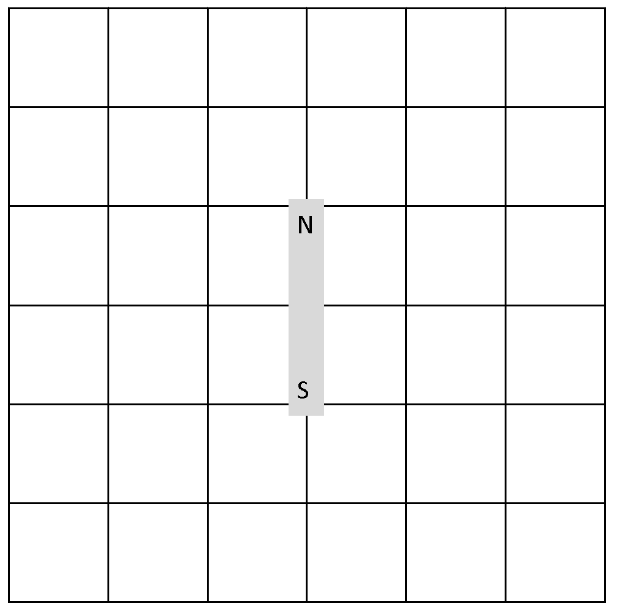

1. Now check the “Show Field” box. How does the direction of the field compare to the arrows you drew with your compass?

The Arrows on the show field correspond the arrows of the compass at those specific places on the electric field.

1. By convention we say that the magnetic field due to a bar magnet points away from North and into South. Does this agree with the arrows in your drawing? Resolve any inconsistencies.

Yes for the most part that is true it points almost always away from the north to the south pole, however at the center point the compass points vertically along the bar magnet.

1. Describe how you can use a set of compasses to determine the direction of a magnetic field.

If you draw lines tangent to the direction of the compass at various points it will follow the magnetic field lines.

**Challenge Problem:** A compass is actually a tiny magnet. The red part of the compass corresponds to its North Pole. Based on this information, why does the red part of the compass point away from North and into South?

**The North side of the compass is attracted to the sound pole of the magnet. This is due to the behavior of opposite sides of magnets attracting.**

**II. The Electromagnet**

In the same simulation, switch to the “Electromagnet” tab and make sure that the “Show Field” box is unchecked.

A coil of wire with a current running through it is an electromagnet.

1. Move the compass around the coil. How does it compare to the bar magnet?

It acts in a similar way the north side is the left side and the south side is the right side of the coil.

1. Where is the North Pole of the electromagnet? (e.g. above / below /to the right / to the left of the coil?)

The north pole is to the left of the coil.

1. Use the switch on the battery to reverse the battery (shown as a backwards battery in the simulation). Does this change the behavior of the compass? Hint: use the compass again to find the North Pole of the electromagnet in this configuration.

This changes the poles of the coil, making the north side now the right side of the magnet.

*A quick way to determine the location of the North pole of a current carrying loop is to curl your fingers in the direction of the current and stick out your thumb. Your thumb indicates the side on which the North Pole of your loop is located.*

1. Try using this Right Hand Rule (RHR) for the situations above. Is the RHR consistent with your answers to questions B and C? Resolve any discrepancies.

Yes the right hand rule properly displays the direction of the magnetic field due to the flow of current, for each direction.

1. Use the RHR to determine where the North and the South poles are located for the following current carrying loops. The arrow shows the direction of the current. Label the North and the South side of each loop.

|  |  |  |  |
| --- | --- | --- | --- |
|  |  |  |  |

**III. The Pickup Coil**

Now switch over to the “Pickup Coil” tab. Make sure the area is set to 50% and set the number of loops to one.

1. Quickly move the magnet through the loop. What do you see?

While the magnet is moving through, during the time the magnet is in motion the bulb lights up

1. Explain what happens in terms of the principles of induction.

Charge is generated due to the magnet moving through the coil, it generates an electric force that in turn powers the bulb. The magnet forces the electrons to move generating an electric force due to the induction caused by the magnet on the coil.

1. Try adjusting various parameters in the simulation:

Increase the number of loops to three and move the magnet through again. What changes and how?

The brightness of the bulb increases when the number of coils is increased and the battery is moved through.

How does the brightness of the bulb change if you lower the strength of the magnet?

The brightness decreases when the strength of the battery is lowered.

How does the brightness of the bulb change if you increase the area of the loop(s)?

The Brightness also decreases because the distance the electrons moves is increased.

Faraday’s Law says the induced EMF depends on the change in flux. Use Faraday’s law to explain your observations.

The total flux traveling through the wire is decreasing because of both the increase in distance and the decrease of magnet strength, this is consistent with a decrease in EMF because the total change in flux is lower.

1. Does the brightness of the bulb depend on the direction you move the magnet through the loop (right to left versus left to right)? If so, describe how.

There doesn’t seem to be a difference in the brightness of the bulb depending on the direction the magnet passes through the loop.

1. Check that the ‘Show electrons’ box is ticked so you can see the electrons in the wire. Does the direction the electrons move depend on the direction you move the magnet through the loop (right to left versus left to right)? If so, describe how.

Yes the direction of the electrons changes in that it flows in opposite directions depending on which direction the magnet moves through the coil.

## IV. Induced currents and Lenz’ Law

### A copper wire loop is placed in a uniform magnetic field as shown. Determine whether there would be a current through the wire of the loop in each case below and if so what direction. Explain your reasoning.

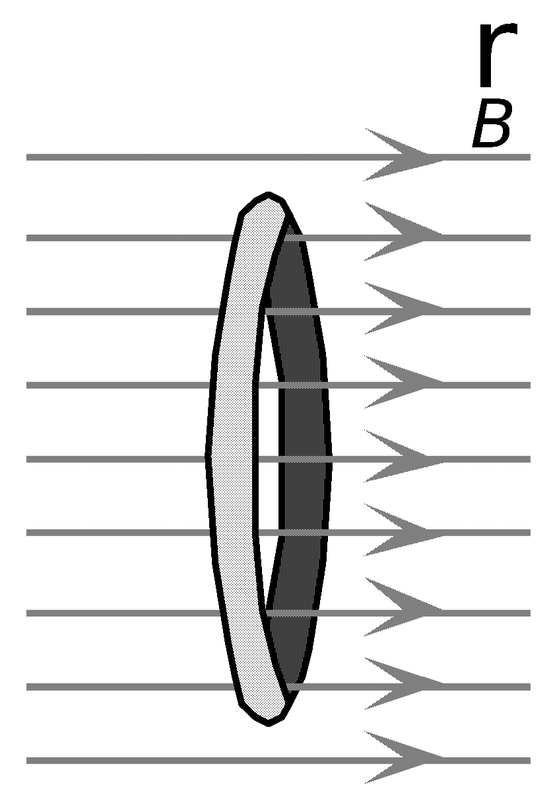

• The loop is stationary.

The loop would not generate any current because the field is constant

• The loop is moving to the right.

The loop would not generate any current because the field would remain constant

• The loop is moving to the left.

The loop would not generate any current because the field would remain constant

### Suppose that the loop is now placed in the magnetic field of a solenoid as shown. Determine whether there would be a current through the wire of the loop in each case below. If so, give the direction of the current. Explain your reasoning.

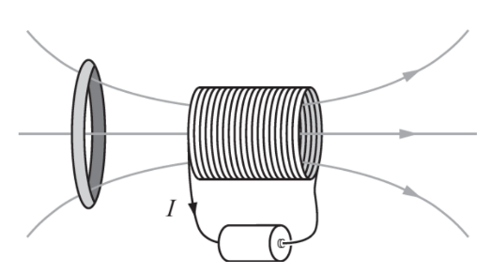• The loop is stationary.

The flux would remain constant thus no current would be generated.

• The loop is moving toward the solenoid



Current would be produced because the flux would

Change.



• The loop is moving away from the solenoid.

Current would be produced because the flux would

Change.



*Lenz’ Law says that “The flux due to the loop always opposes the change in the flux due to the external magnetic field.” Another way to say this is “The induced current produces a magnetic field that opposes the change in magnetic flux through the loop.*

1. Are your responses consistent with Lenz's Law? Explain.

*Yes the is only generated when there is a change in magnetic flux moving through the loop.*

## V. Application: Generator

Now switch over to the “Generator” tab. In this part of the simulation a stream of water turns a wheel with a magnet causing the magnet to spin. Nearby, a lightbulb attached to a coil of wire lights up. Explain how a generator works based on Faraday and Lenz’ Laws.

The magnet is rotated causing a change in flux thus generating a current through the coil powering the bulb. This is consistent with faradays change in flux causing flux, if we increase the rpm we would see more power generated due to the increase in change in time.

## Challenge Problem: Electric Motor



A basic electric motor can be made from a magnet, a coil of wire, and to a battery. The battery is connected to either side of the loop. A schematic is shown at right. 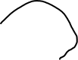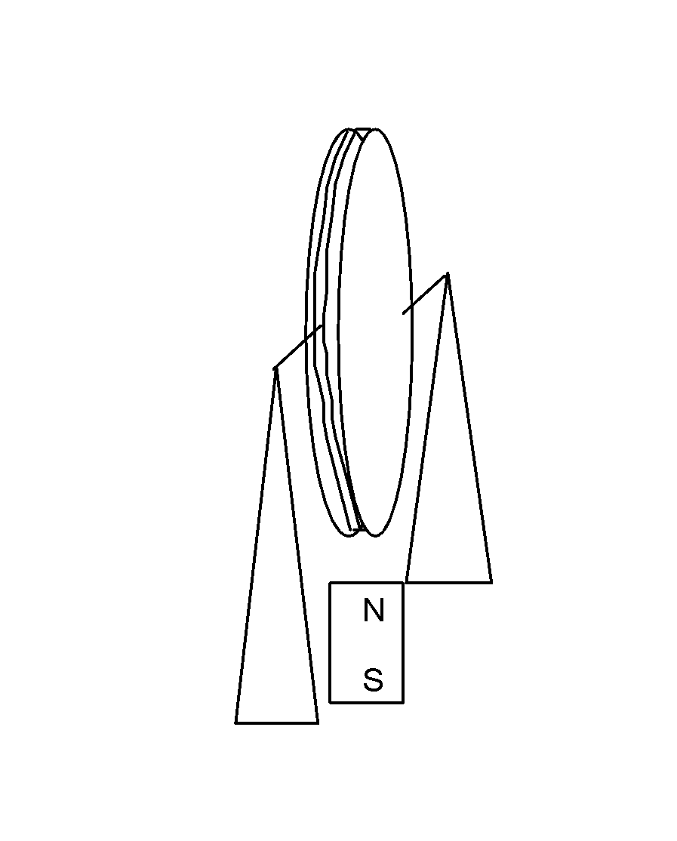

battery

Discuss why this set-up would cause the loop of wire to spin.

The electrons would move through the wire causing the wire to generate

A electric field that would be effected by the magnet causing the loop to spin.